NOTE: Aquavation custom bottles are purchased at a price at or lower than a typical race t-shirt price. Most of our races buy our product and we are a vendor. Several have committed sponsors who we have seen buy the bottle sponsorship. Work with our Concierge for pricing information.

With this document, we have made it easy for race committees to add the Aquavation® event sponsorship concept to your communications. All you do is edit then copy and paste page 2.

More about Aquavation® here.

Aquavation® Primer
Your sponsor is providing a personalized gift bottle for each race participant with their digital logo included on the bottle.
You are offering your potential sponsor the right to be at the event interacting with each race participant as they come to claim their personalized ‘Trophy Bottle’ gift. Talk about cultivating a positive brand experience!

[Edit then Copy and Paste the following:]

Be the memorable sponsor at our Marathon. Together, we will partner with Aquavation® to create a ‘Trophy Bottle’ which will be the gift our runners will cherish most.
Don’t believe us? Click HERE. Each bottle will have your logo in high resolution digital imaging.
As our sponsor your will have the unique opportunity to position at a pick up tent interacting with your target market to provide the most fun gift experience ever seen at a marathon.

Sole Aquavation® Bottle Sponsor*
Limited to One
Market Price

- You will be the exclusive Sponsor giving a custom bottle gift to each runner.
- Name & digital logo on personalized water bottles presented to each registered race participant with your brand carried into the community long after the event.
- A branded tent for your team in a prominent place.
- Brand presence at the event where your representatives can engage your target market with a fun gift giving interaction.
- You may also present race finishers with your logo’d merchandise and give-aways of your choosing.
- Placement on the web site thank you page with link to Sponsor’s Web sit

* Large events have been known to tier sponsorship and have up to three sponsors.
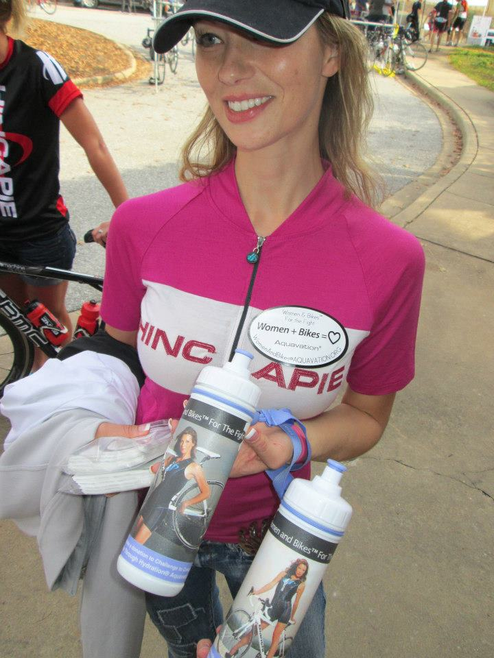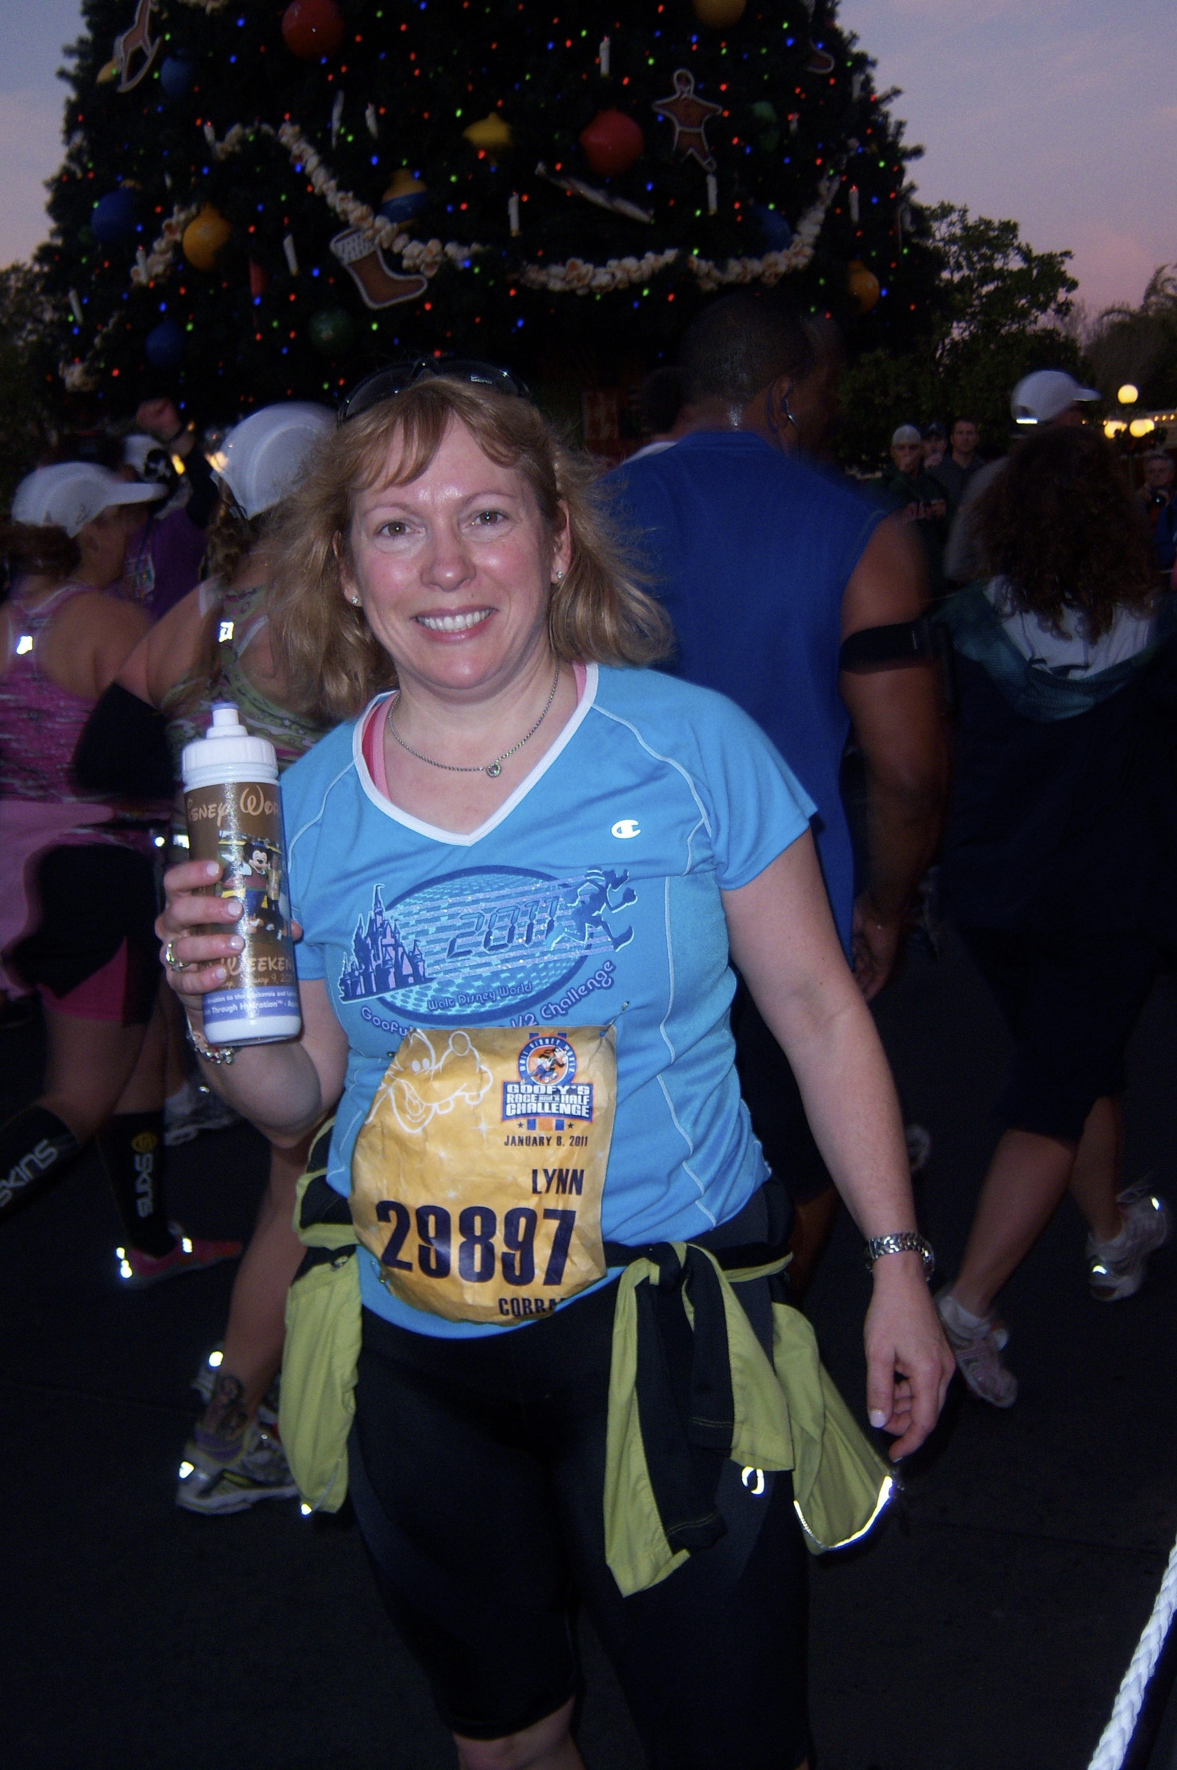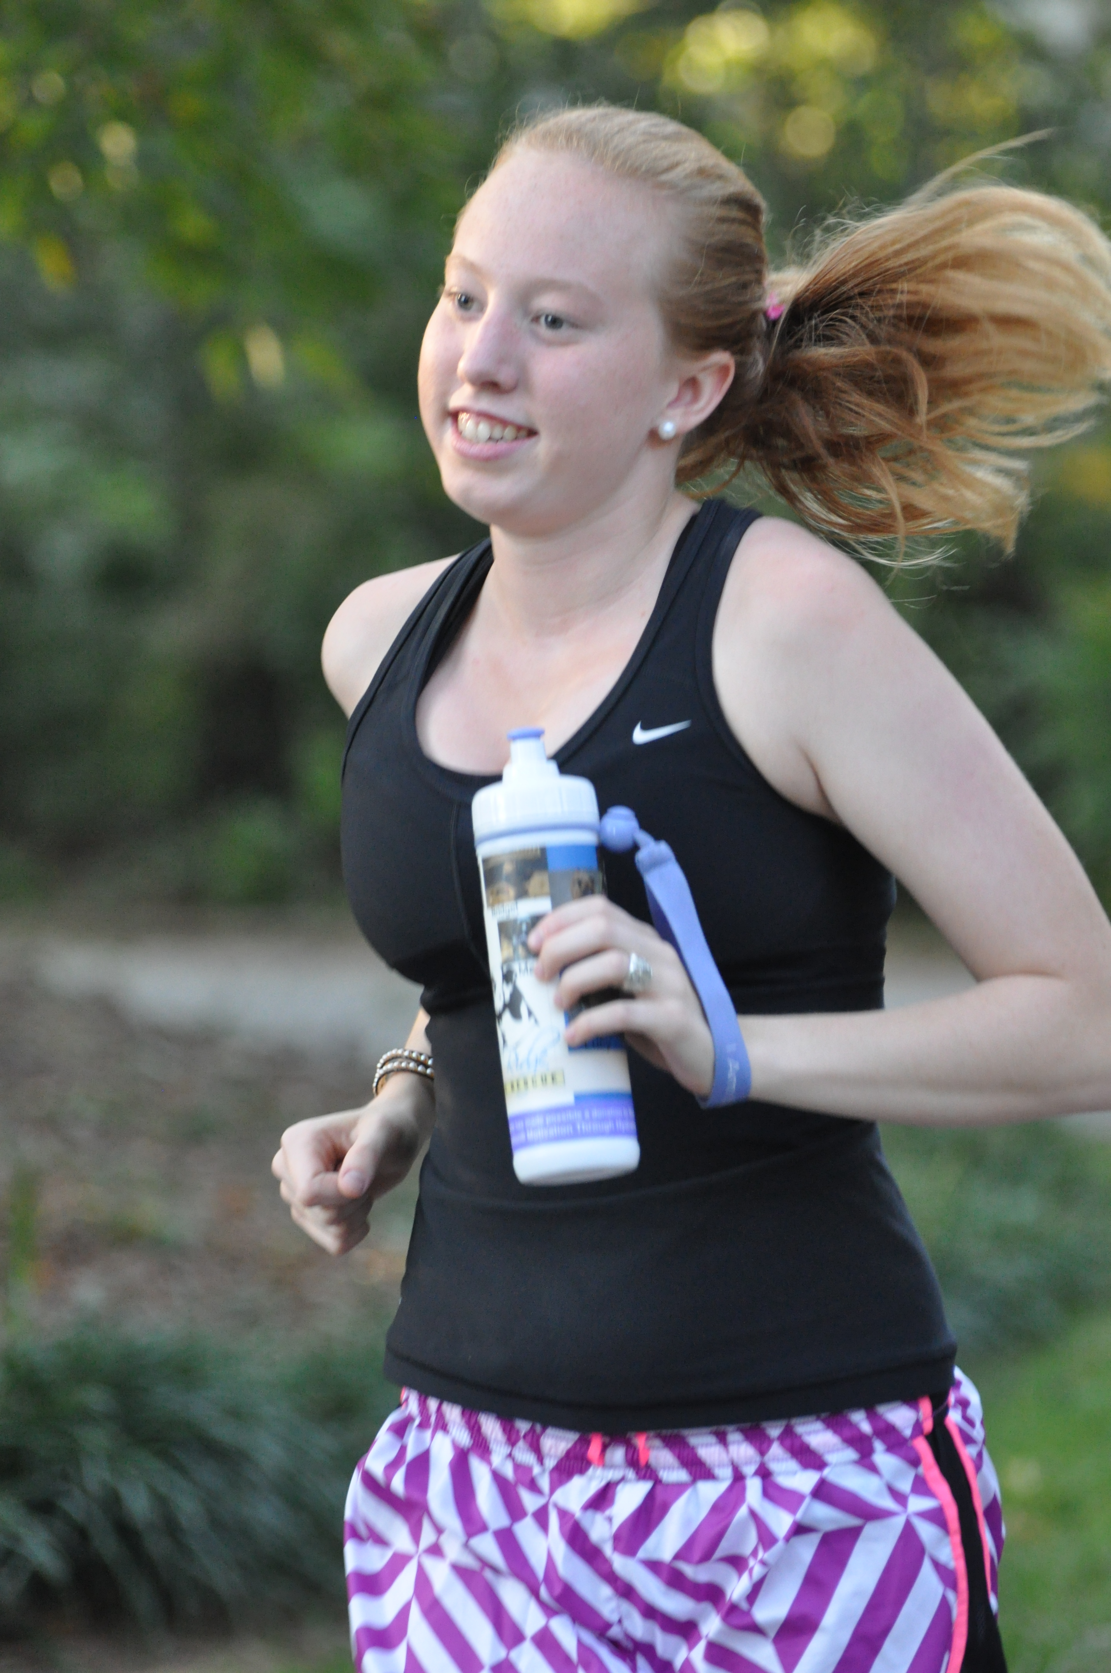

Contact: Concierge@Aquavation.Org

